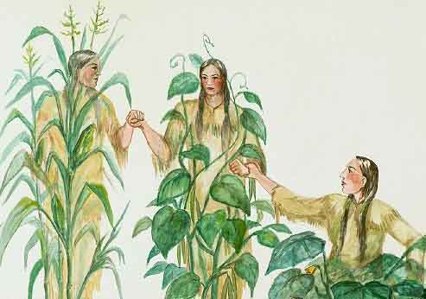

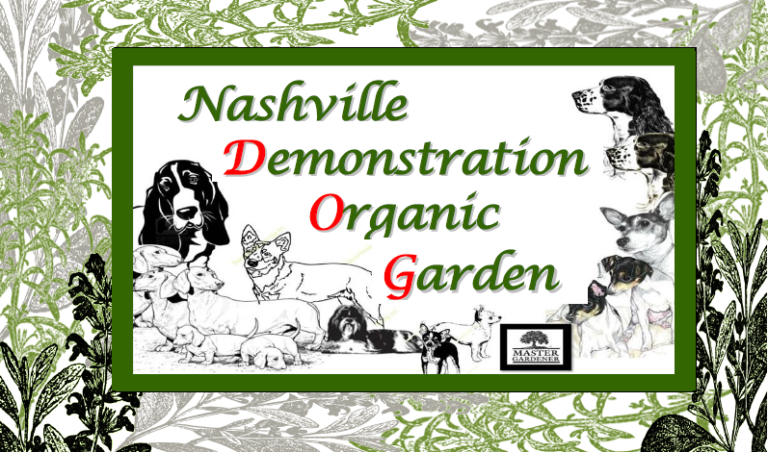



**Today in the Garden!**

Visit the garden to learn about Companion Planting and pick up free petunia and marigold plants for your garden!